**Web of Conferences – 170 x 250 mm paper size one column format**

*Ruiguang* Gan1, [1], *Xuefeng* Chen2 and *Xinghui* Zhou2

1School of xxxx, yyyy University, Beijing, China

2School of aaaa, bbbb University, Hangzhou, China

**Abstract.** You should leave 8 mm of space above the abstract and 10 mm after the abstract. The heading Abstract should be typed in bold 9-point Arial. The body of the abstract should be typed in normal 9-point Times in a single paragraph, immediately following the heading. The text should be set to 1 line spacing. The abstract should be centred across the page, indented 17 mm from the left and right page margins and justified. It should not normally exceed 200 words.

**Keywords:** First paragraph, page numbers, good quality.

**1 Page layout**

Use 170 x 250 mm paper size (W x H mm) and adjust the margins to those shown in the Table 1. The final printed area will be 130 x 210 mm. Do not add any page numbers.

Do not add any page numbers. Do not add any page numbers. Do not add any page numbers. Do not add any page numbers. Do not add any page numbers. Do not add any page numbers. Do not add any page numbers.

**1.1 Formatting the title, authors and affiliations**

*1.1.1 Formatting the title*

The title is set in bold 16-point Arial, justified. The first letter of the title should be capitalised with the rest in lower case. You should leave 22 mm of space above the title and 6 mm after the title.

*1.1.2 Formatting author names and author affiliations*

The style for the names is First Names, typed in italic 10-point Times, then Last Name, typed in 10-point Times, with a comma after all except the last author, which is separated by comma + “and”. Do not use academic titles.

Affiliations of authors should be typed in 9-point Times. They should be preceded by a numerical superscript corresponding to the same superscript after the name of the author concerned. Please ensure that affiliations are as full and complete as possible and include the country.

**1.2 Formatting the text**

The first paragraph after a section or subsection should not be indented; subsequent paragraphs should be indented by 5 mm.

The use of sections to divide the text of the paper is optional and left as a decision for the author. Where the author wishes to divide the paper into sections the formatting shown in Table 1 should be used.

**Table 1.** Formatting sections, subsections and subsubsections.

|  |  |  |  |
| --- | --- | --- | --- |
|  | Font | Spacing | numbering |
| Section | 12-point Arial bold | 6 mm before 3 mm after | 1, 2, 3, etc. |
| subsection | 10-point Arial bold | 6 mm before 3 mm after | 1.1, 1.2, 1.3, etc. |
| subsubsection | 10-point Arial Italic | 6 mm before 3 mm after | 1.1.1, 1.1.2, 1.1.3, etc. |

The use of sections to divide the text of the paper is optional and left as a decision for the author. Where the author wishes to divide the paper into sections the formatting shown in Table 1 should be used.

**2 Figures and tables**

Figures and tables, as originals of good quality and well contrasted, are to be in their final form, ready for reproduction.

**2.1 Captions/numbering**

Captions should be typed in 9-point Times. They should be centred above the tables and flush left beneath the figures.

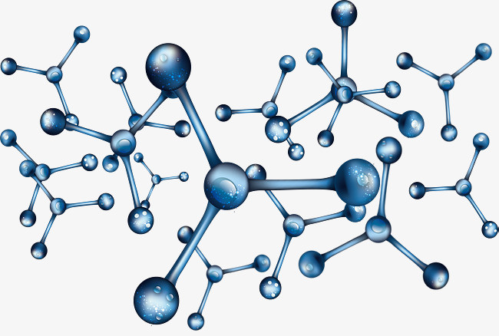

**Fig. 1.** Caption of the Figure 1. Below the figure.

Place the figure as close as possible after the point where it is first referenced in the text. If there is a large number of figures and tables it might be necessary to place some before their text citation.

**3 Equations and mathematics**

Equations should be centred and should be numbered with the number on the right-hand side.

*T*s (*l,t*) = *T*g (*l,t*) (1)

*T*s (*l,t*) = *T*g (*l,t*) *T*b (*x*   , *t*) = 0 (2)

Use italics for variables (*u*) and bold (**u**) for vectors. The order for brackets should be {[()]}, except where brackets have special significance.

**Acknowledgments**

This work was financially supported by xxx fund.

**References**

1. A. Mecke, I. Lee, J.R. Baker jr., M.M. Banaszak Holl, B.G. Orr, Eur. Phys. J*.* E **14**, 7 (2004)
2. M. Ben Rabha, M.F. Boujmil, M. Saadoun, B. Bessaïs, Eur. Phys. J. Appl. Phys. (to be published)
3. F. De Lillo, F. Cecconi, G. Lacorata, A. Vulpiani,EPL, **84** (2008)
4. L. T. De Luca, *Propulsion physics* (EDP Sciences, Les Ulis, 2009)

1. Corresponding author: 1234567@888.com